**Implementing the Singleton Pattern**

**Logger.java**

public class Logger {

    private static Logger instance;

    private Logger() {

        System.out.println("Logger Initialized");

    }

    public static Logger getInstance() {

        if (instance == null) {

            instance = new Logger();

        }

        return instance;

    }

    public void log(String message) {

        System.out.println("[LOG] " + message);

    }

}

**TestLogger.java**

public class TestLogger {

    public static void main(String[] args) {

        Logger logger1 = Logger.getInstance();

        Logger logger2 = Logger.getInstance();

        logger1.log("This is a log message.");

        if (logger1 == logger2) {

            System.out.println("Both logger1 and logger2 refer to the same instance.");

        } else {

            System.out.println("Different instances exist (Singleton failed).");

        }

    }

}

**Output:**

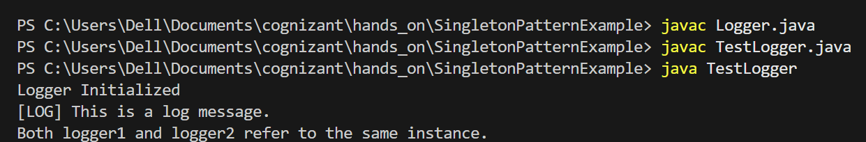

**Implementing the Factory Method Pattern**

**Document.java**

public interface Document {

    void open();

}

**WordDocument.java**

public class WordDocument implements Document {

    @Override

    public void open() {

        System.out.println("Opening Word document...");

    }

}

**PdfDocument.java**

public class PdfDocument implements Document {

    @Override

    public void open() {

        System.out.println("Opening PDF document...");

    }

}

**ExcelDocument.java**

public class ExcelDocument implements Document {

    @Override

    public void open() {

        System.out.println("Opening Excel document...");

    }

}

**DocumentFactory.java**

public abstract class DocumentFactory {

    public abstract Document createDocument();

}

**WordDocumentFactory.java**

public class WordDocumentFactory extends DocumentFactory {

    @Override

    public Document createDocument() {

        return new WordDocument();

    }

}

**PdfDocumentFactory.java**

public class PdfDocumentFactory extends DocumentFactory {

    @Override

    public Document createDocument() {

        return new PdfDocument();

    }

}

**ExcelDocumentFactory.java**

public class ExcelDocumentFactory extends DocumentFactory {

    @Override

    public Document createDocument() {

        return new ExcelDocument();

    }

}

**Main.java**

public class Main {

    public static void main(String[] args) {

        DocumentFactory wordFactory = new WordDocumentFactory();

        Document wordDoc = wordFactory.createDocument();

        wordDoc.open();

        DocumentFactory pdfFactory = new PdfDocumentFactory();

        Document pdfDoc = pdfFactory.createDocument();

        pdfDoc.open();

        DocumentFactory excelFactory = new ExcelDocumentFactory();

        Document excelDoc = excelFactory.createDocument();

        excelDoc.open();

    }

}

**Output:**

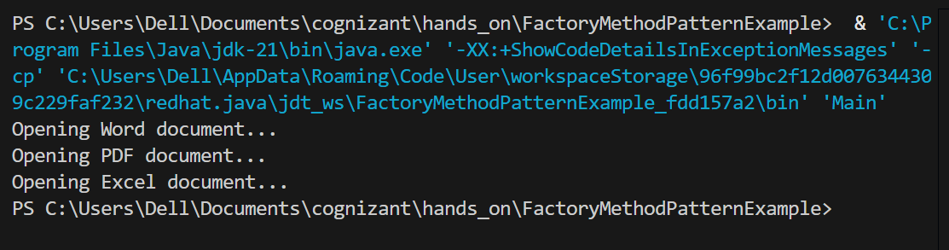

**E-commerce Platform Search Function:**

Big O notation describes the upper bound of an algorithm's running time.

It helps us analyze how the performance of an algorithm scales with input size n.

|  |  |  |  |
| --- | --- | --- | --- |
| **Algorithm** | **Best Case** | **Average Case** | **Worst Case** |
| **Linear Search** | O(1) | O(n) | O(n) |
| **Binary Search** | O(1) | O(log n) | O(log n) |

**Product.java**

public class Product {

    int productId;

    String productName;

    String category;

    public Product(int productId, String productName, String category) {

        this.productId = productId;

        this.productName = productName;

        this.category = category;

    }

    @Override

    public String toString() {

        return productId + " - " + productName + " (" + category + ")";

    }

}

**Search.java**

import java.util.Arrays;

import java.util.Comparator;

public class Search {

    public static Product linearSearch(Product[] products, String name) {

        for (Product p : products) {

            if (p.productName.equalsIgnoreCase(name)) {

                return p;

            }

        }

        return null;

    }

    public static Product binarySearch(Product[] products, String name) {

        int left = 0, right = products.length - 1;

        while (left <= right) {

            int mid = (left + right) / 2;

            int cmp = products[mid].productName.compareToIgnoreCase(name);

            if (cmp == 0) return products[mid];

            else if (cmp < 0) left = mid + 1;

            else right = mid - 1;

        }

        return null;

    }

    public static void sortByName(Product[] products) {

        Arrays.sort(products, Comparator.comparing(p -> p.productName.toLowerCase()));

    }

}

**Main.java**

public class Main {

    public static void main(String[] args) {

        Product[] products = {

            new Product(101, "Laptop", "Electronics"),

            new Product(102, "Shoes", "Footwear"),

            new Product(103, "Mobile", "Electronics"),

            new Product(104, "Chair", "Furniture"),

            new Product(105, "Book", "Stationery")

        };

        System.out.println("Product List (Original Order):");

        printProducts(products);

        System.out.println("\nLinear Search for 'Mobile':");

        Product result1 = Search.linearSearch(products, "Mobile");

        System.out.println(result1 != null ? "Found: " + result1 : "Not found");

        System.out.println("\nSorting products by name for Binary Search...");

        Search.sortByName(products);

        System.out.println("Product List (After Sorting):");

        printProducts(products);

        System.out.println("\nBinary Search for 'Mobile':");

        Product result2 = Search.binarySearch(products, "Mobile");

        System.out.println(result2 != null ? "Found: " + result2 : "Not found");

    }

    public static void printProducts(Product[] products) {

        for (Product p : products) {

            System.out.println(" " + p);

        }

    }

}

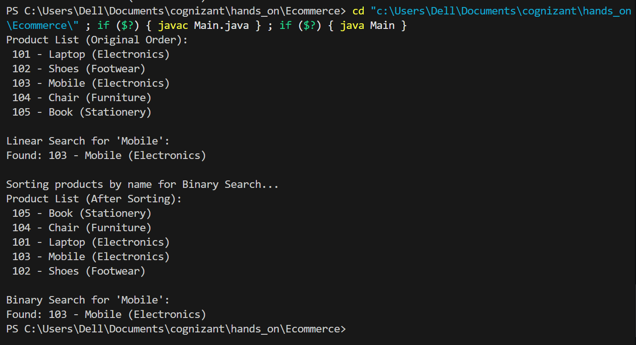

**Financial Forecasting:**

Recursion is when a method calls itself to solve a smaller instance of the same problem.

It simplifies complex problems by breaking them down into base cases and recursive cases.

**FinancialForecast.java**

public class FinancialForecast {

    public static double forecastValue(double initialAmount, double rate, int years) {

        if (years == 0) {

            return initialAmount;

        }

        return forecastValue(initialAmount, rate, years - 1) * (1 + rate);

    }

    public static void main(String[] args) {

        double initialAmount = 10000;

        double annualGrowthRate = 0.05;

        int years = 10;

        double futureValue = forecastValue(initialAmount, annualGrowthRate, years);

        System.out.printf("Future value after %d years: Rs.%.2f\n", years, futureValue);

    }

}

**Output:**

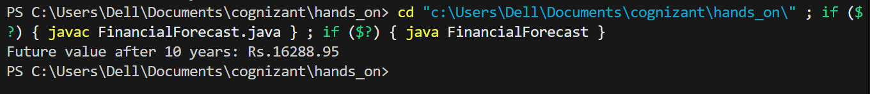

**Time Complexity: O(n)**

**Optimization: Use iterative approach**